Name: Allen Taylor
CMIS 310
HOMEWORK #4 – Week #4

This homework is worth 10% of your course grade.

Read each problem carefully. Failure to follow the instructions for a problem will result in a zero score for that problem.

Submit the completed Homework via Assignment in LEO.

- Do Exercise 2 in Chapter 5 (A Closer Look at Instruction Set Architectures) of Null and Lobur

Show how the following values would be stored by byte-addressable machines with 32-bit words, using little endian and then big endian format. Assume that each value starts at address 10^16. Draw a diagram of memory for each, placing the appropriate values in the correct (and labeled) memory locations.
a) 0x456789A1
b) 0x0000058A
c) 0x14148888

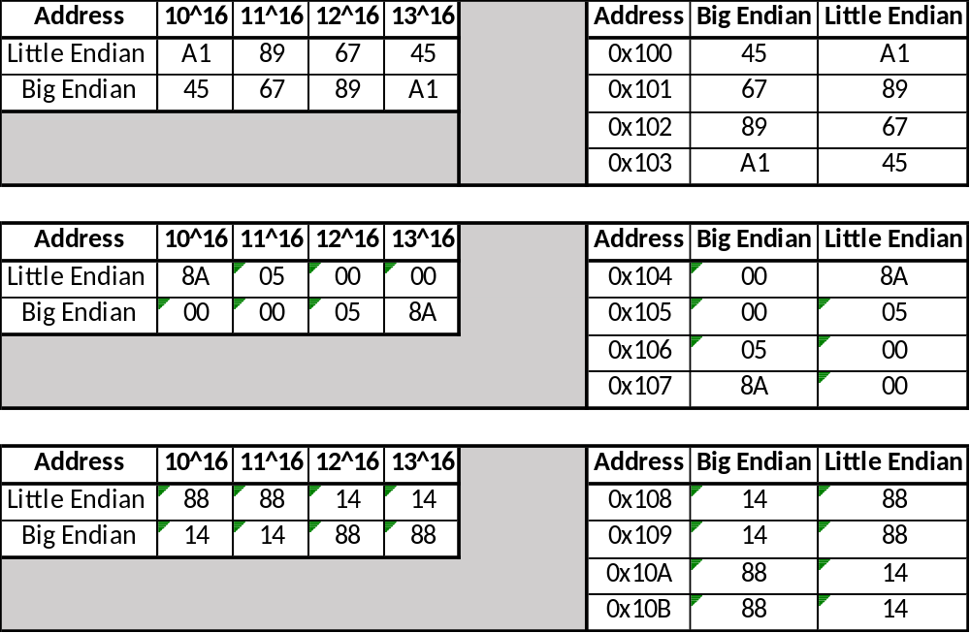

- Do Exercise 12 in Chapter 5 (A Closer Look at Instruction Set Architectures) of Null and Lobur

Convert the following expressions from infix to reverse Polish (postfix) notation.

a) X × Y + W × Z + V × U

XY*WZ*+VU*+

b) W × X + W × (U × V + Z)

WX*WUV*Z+*+

c) (W × (X + Y × (U × V))) / (U × (X + Y))

WXYUV**+*UXY+*/

- Do Exercise 14 in Chapter 5 (A Closer Look at Instruction Set Architectures) of Null and Lobur

Convert the following expressions from reverse Polish notation to infix notation.

a) W X Y Z − + ×

(W*(X+(Y−Z)))

b) U V W X Y Z + × + × +

(U+(V*(W+(X*(Y+Z)))))

c) X Y Z + V W − × Z + +

X+(((Y+Z)*(V-W))+Z)

- Do Exercise 22 in Chapter 5 (A Closer Look at Instruction Set Architectures) of Null and Lobur

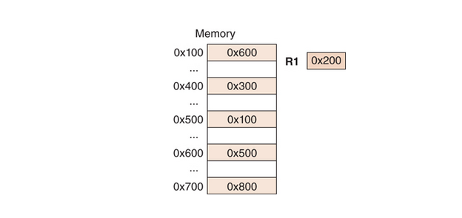

Mode | Value
Immediate | 0x500
Direct | 0x100
Indirect | 0x600
Indexed | 0x800

- Do Exercise 28 in Chapter 5 (A Closer Look at Instruction Set Architectures) of Null and Lobur

The memory unit of a computer has 256K words of 32 bits each. The computer has an instruction format with four fields: an opcode field; a mode field to specify one of seven addressing modes; a register address field to specify one of 60 registers; and a memory address field. Assume an instruction is 32 bits long. Answer the following:

a) How large must the mode field be?

3 Bits

b) How large must the register field be?

6 Bits

c) How large must the address field be?

18 Bits

d) How large is the opcode field?

5 Bits

